Naps of the Bible Maren C. Tirabassi | 2018
"So God blessed the seventh day and hallowed it, because on it God rested from all the work of creation." - Genesis 2:3
Jacob ran, scared to death of his brother Esau who was … huge. Exhausted in the wilderness, he put his head on a rock and dreamed a legislature of angels. Jacob woke knowing God was in every scary place or runaway journey, but only because sleep gave the dreaming a chance. Joseph of Nazareth planned to send away his beloved Mary, because that's how being hurt and angry works. Then he decided to sleep on it, and the rest was ... well, Christmas! Jesus was taking a power nap in the boat between healings and teachings when a storm blew up. They had to shake him awake before he could say "peace, be still." Only later he complained, "O you of little naps …"
And that's not mentioning Nebuchadnezzar's nightmare of conscience, Jonah's snooze below decks before taking responsibility for his actions, the warning to the magi that there is always another way home, or the raising of Eutychus, the teenager who fell out the window reminding us that long sermons can be a form of melatonin.
Long ago and this week, the chance to actually experience a dream of hope, the pause that shifts an emotion-driven decision, the renewal of strength and faith to face any storm—they all come from sleep. Sleep gives energy, focus, creativity. Sleep weaves the frayed memory, improves the unreliable temper, and always makes working with the ragtag, clueless, practically disciple-esque folks in our resistance possible.
Prayer God, who takes us from being left in the dust to ribs of companionship in one deep sleep, we thank you for always being there when we lie down and when we rise up.
Maren C. Tirabassi is Pastor of the Union Congregational UCC of Madbury, NH.

UPCOMING EVENTS

- Nashua Soup Kitchen Nov 10 Meet in the Mason Church parking lot at 3:15 to carpool to the Soup Kitchen, back by 7 pm. This is an opportunity to help provide a meal, and friendliness to those who are in need. Susan Suokko has knitted winter hats which we will give the Soup Kitchen. We serve food, beverages, and kindness.

- Nov 10, 2018 Church Cleanup Come from 9 -12 pm to help with a list of jobs that will keep our Church as sparkling on the outside as inside our spiritual selves. Bring tools you prefer to use, and gloves, etc. There will something for everyone! Including hot beverages, and a snack.
- Nov 11, 2018 5:30 share soup/bread. 6:30 Begin movie & discussion. The Conversation---End of life issues How do you draw the line between saving a life and prolonging a dying? We will ask the questions, and have some guided answers from Atul Gawande's book Being Mortal and Kate Butler's book Knocking on Heaven's Door. There's more to it than a "living will" and the discussions that should/could be made before you or your loved ones reach a point where you wish you had made yourself clear. The 5 Wishes booklet from Aging with Dignity, and the booklet from Threshold Care in Wilton, NH will also guide us. Your stories and experiences will be valuable additions to this discussion. Open to all
- CVTC Community Volunteer Transportation Company If you know someone in Mason who needs a ride, to doctor appointments and more, call (877) 428-2882 Meanwhile if you would like to be a volunteer driver, call 1-877-428-2882 ext 5 for information on mileage reimbursement, insurance, etc. You can be a driver once or twice a week, or once a month, you decide on what your schedule allows! Call for more info. For rides contact on line line: https://www.nh.gov/dot/programs/rideshare/index.htm.

Living Room Coffee House November 17, from 6:30 to 9ish Our Coffee House also has coffee, some good food, and talented open mic performers. Derek Russell Fimbel is the featured performer. Now here is a good Music farmer! Ya just cant help but like him. He’s been planting seeds of music all around. Hey!….Not only does Derek perform, but he is a catalyst for live music in the Souhegan area and beyond….. Something is happening. Can you hear it? SPT
- Mason Church Trunk and Treat This event went very well. There were at least 90 children, lots of dressed up adults too, and our fire and police departments were on hand as well. Makes for a fun evening, and for frolicking in the shadows.

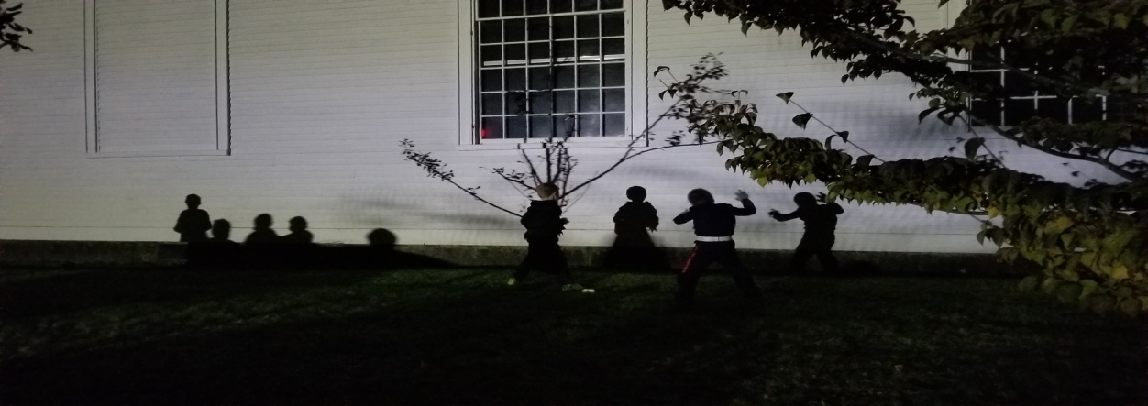
- ADVENT is coming! Dec 2nd is the first Sunday. Meet the Deacons and help ready the church on Dec 1 at 9 am A few hours of work done with love.

- Bystander CPR In the spring we had two classes for Bystander CPR, and the participants also received the critical instructions on how to use an AED (automated external defibrillator) Simple instructions, and practice in a 2 hour class. If you are interested, we will be glad to host another class. Please contact Kathy Chapman, chapman.kathy@gmail.com We have our AED for Mason Church, and we all should know how
to use this simple, lifesaving device! NEW “Bystander First Aid” Our instructor for the Bystander CPR has agreed to teach a “more than bandaids” first aid class. What can you do to stop bleeding? Stabilize a person until the ambulance gets there, and more. If you have an interest in this class, contact Kathy Chapman Chapman.kathy@gmail.com for more information.
Lending Library Books and Music, a Blessing. Notice the fine bookshelf in Fellowship Hall that has books for lending—all nicely organized, and alphabetized by a church angel. Steve Tamulonis has contributed some CDs for lending/listening. Please sign them out, and return in a reasonable time. Enjoy this mission/blessing.
Prayer shawls always needed, free yarn available. Spend some time by joining the knitters of Mason Church in prayerful knitting. Let us know if you need yarn or pattern. If you know of someone who needs the warmth and prayers of a shawl please contact: Susan Suokko at Usercat2@comcast.net or 941-920-0270 or Michelle Scott 878-1680 Attention knitters: Go to http://twillnh.com/calendar-4/ and check out Sandy’s website, and the schedule for activities there.
Are you listening, caring, sharing?

- Wally and Gretchen Brown Since her broken hip last spring, and her rehab, Gretchen has lots of challenges. Call Wally (878-1481) if you want an update on how she’s doing, or better yet, stop by and see Gretchen. This is a time when she needs her friends more than ever!
- Karin Eisenhaure Karin has had some major repairs on her knee and is now at home. She’s not able to drive yet but the brace will come off in early December, so she will become more mobile. So stop off for a quick or long visit, depending on Karin’s needs and your schedule! She might need some meals but ask first since she got a bit overwhelmed with food when she first came home! Thank you to everyone. She is used to being around people, helping Curt, and doing for herself, and appreciates your offers of help! Phone 878-2675 or cell 732-2191. Give her plenty of time to answer, just call back after 7 or more rings, and also when stopping by—give plenty of time for her to get to the door, or listen for her to tell you to come in.
- Curt Dunn Curt is going to a facility in Bedford on October 9th, as our winters make it challenging for people to do homecare! More info coming on how to contact him, and where to visit, call Rev. Veronica for info at 878-1684
- Laila Washburn Laila lives at Summer Hill Assisted Living in Peterborough. She loves company, and cards. At 99, everyday is treasured. . Laila Washburn, Summer Hill, 183 Old Dublin Rd, Peterborough, NH 03458. Call ahead if you have questions. 924-6238
- Do you have new neighbors? We have baskets we can put together with some special items made in Mason, and some info on Town activities and church info. Let me know: Michelle 878-1680 or miscott39@gmail.com

